**FIU 2017 Spring**

**ESI 6455**

**Advanced Engineering Project Management**

**Yezehao Huai (5965823)**

**Chapter 9 HW: P326 E5**

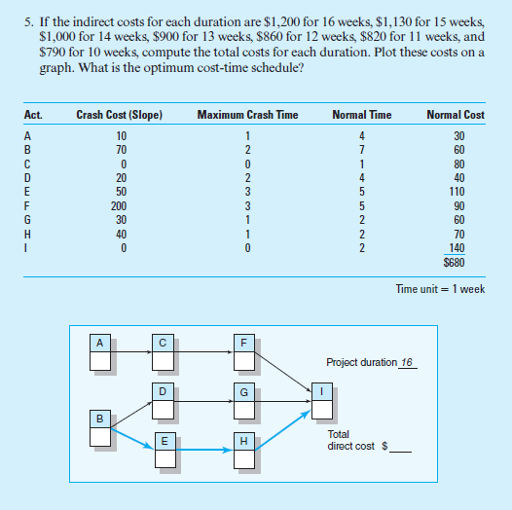

|  |
| --- |
| C |
|  |

|  |
| --- |
| F |
|  |

|  |
| --- |
| A |
|  |

|  |
| --- |
| D |
|  |

|  |
| --- |
| G |
|  |

|  |
| --- |
| I |
|  |

|  |
| --- |
| B |
|  |

|  |
| --- |
| E |
|  |

|  |
| --- |
| H |
|  |

Project duration___ Total direct cost $___

|  |
| --- |
| C |
|  |

|  |
| --- |
| F |
|  |

|  |
| --- |
| A |
|  |

|  |
| --- |
| D |
|  |

|  |
| --- |
| G |
|  |

|  |
| --- |
| I |
|  |

|  |
| --- |
| B |
|  |

|  |
| --- |
| E |
|  |

|  |
| --- |
| H |
|  |

Project duration___ Total direct cost $___ Activities changed

|  |
| --- |
| C |
|  |

|  |
| --- |
| F |
|  |

|  |
| --- |
| A |
|  |

|  |
| --- |
| D |
|  |

|  |
| --- |
| G |
|  |

|  |
| --- |
| I |
|  |

|  |
| --- |
| B |
|  |

|  |
| --- |
| E |
|  |

|  |
| --- |
| H |
|  |

Project duration___ Total direct cost $___ Activities changed

|  |
| --- |
| C |
|  |

|  |
| --- |
| F |
|  |

|  |
| --- |
| A |
|  |

|  |
| --- |
| D |
|  |

|  |
| --- |
| G |
|  |

|  |
| --- |
| I |
|  |

|  |
| --- |
| B |
|  |

|  |
| --- |
| E |
|  |

|  |
| --- |
| H |
|  |

Project duration___ Total direct cost $___ Activities changed

|  |
| --- |
| C |
|  |

|  |
| --- |
| F |
|  |

|  |
| --- |
| A |
|  |

|  |
| --- |
| D |
|  |

|  |
| --- |
| G |
|  |

|  |
| --- |
| I |
|  |

|  |
| --- |
| B |
|  |

|  |
| --- |
| E |
|  |

|  |
| --- |
| H |
|  |

Project duration___ Total direct cost $___ Activities changed

|  |
| --- |
| C |
|  |

|  |
| --- |
| F |
|  |

|  |
| --- |
| A |
|  |

|  |
| --- |
| D |
|  |

|  |
| --- |
| G |
|  |

|  |
| --- |
| I |
|  |

|  |
| --- |
| B |
|  |

|  |
| --- |
| E |
|  |

|  |
| --- |
| H |
|  |

Project duration___ Total direct cost $___ Activities changed

|  |
| --- |
| C |
|  |

|  |
| --- |
| F |
|  |

|  |
| --- |
| A |
|  |

|  |
| --- |
| D |
|  |

|  |
| --- |
| G |
|  |

|  |
| --- |
| I |
|  |

|  |
| --- |
| B |
|  |

|  |
| --- |
| E |
|  |

|  |
| --- |
| H |
|  |

Project duration___ Total direct cost $___ Activities changed

|  |  |  |  |
| --- | --- | --- | --- |
| Project Duration | Direct Costs | Indirect Costs | Total Costs |
| 10 | $1290 | $790 | $2080 |
| 11 | 1010 | 820 | 1830 |
| 12 | 930 | 860 | 1790 |
| **13** | **860** | **900** | **1760** |
| 14 | 790 | 1000 | 1790 |
| 15 | 720 | 1130 | 1850 |
| 16 | 680 | 1200 | 1880 |